EXP- 8
Online Learning Platform – MoSCoW & Kano

Aim
To categorize and prioritize platform requirements.

Procedure
1. Create Jira backlog.
2. Add all 6 features.
3. Categorize using MoSCoW.
4. Classify using Kano.
5. Prioritize accordingly.

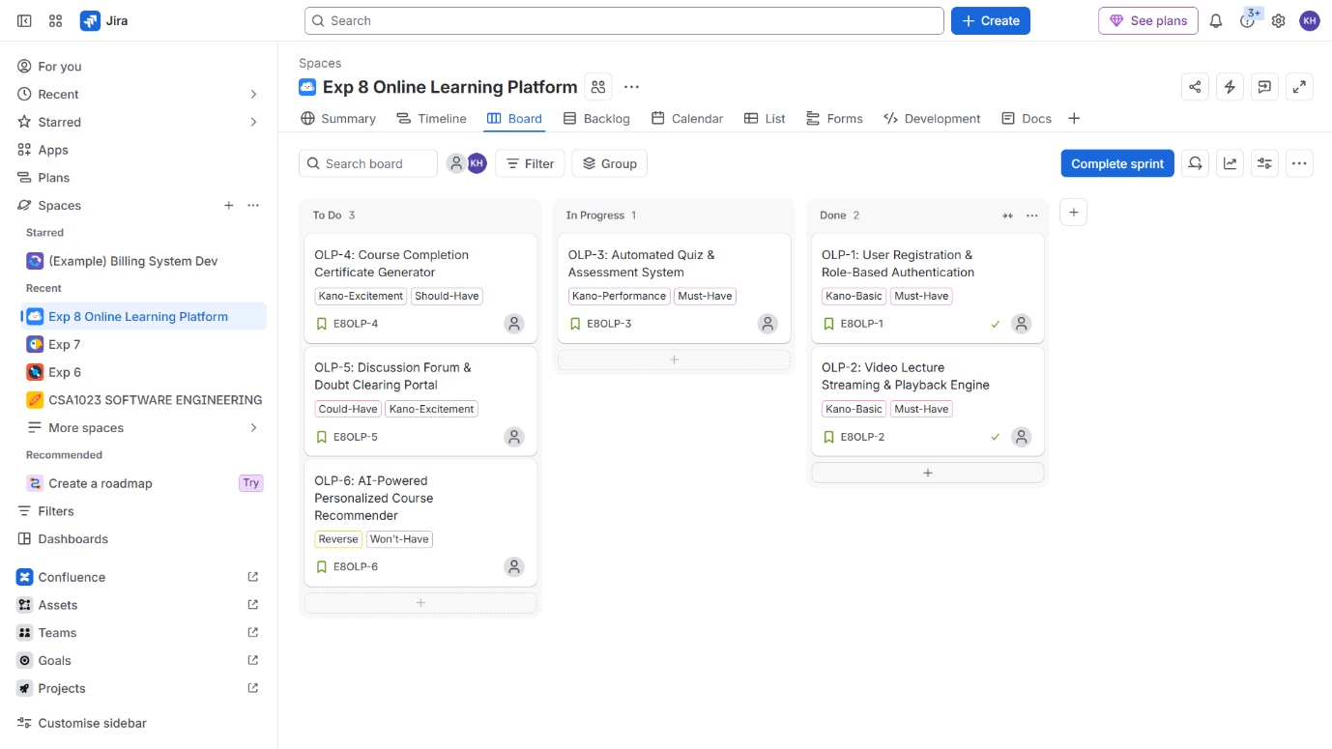

Result: Thus, The Features prioritized based on stakeholder value and satisfaction.

